TEST Plan

**Version History**

|  |  |  |  |  |  |
| --- | --- | --- | --- | --- | --- |
| **Version #** | **Write by** | **Revision Date** | **Approved by** | **Approval Date** | **Outline** |
| 1.0 | Isabelle Ho, Donell Waysome | 28/07/2021 |  |  | Test Plan Create |

**Introduction**

The Test Plan is designed to prescribe the scope, approach, resources, and schedule of all testing activities of the project Intergr8HR.

1. **TEST STRATEGY**

**1.1 Scope of Testing**

**1.1.1 Feature to be tested**

|  |  |  |
| --- | --- | --- |
| **Module Name** | **Applicable Roles** | **Description** |
| **Log in** | Super Agent  Agent  Employee | **Super Agent:** A Super Agent can log into their account with the correct email and password.  **Agent:** An Agent can log into their account with the correct email and password.  **Employee:** An Employee can log into their account with the correct email and password. |
| **Change Password** | Super Agent  Agent  Employee | **Super Agent:** A Super Agent can reset their password if they forget it.  **Agent:** An Agent can reset their password if they forget it.  **Employee:** An Employee can reset their password if they forget it. |
| **Create Ticket** | Super Agent  Agent  Employee | **Super Agent:** A Super Agent can create a new ticket and add a description.  **Agent:** An Agent can create a new ticket and add a description.  **Employee:** An Employee can create a new ticket and add a description. |
| **Assign Ticket** | Super Agent  Agent | **Super Agent:** A Super Agent can assign a ticket to a user.  **Agent:** An Agent can assign a ticket to a user. |
| **Resolve Ticket** | Super Agent  Agent  Employee | **Super Agent:** A Super Agent can resolve a ticket to mark it as complete.  **Agent:** An Agent can resolve a ticket to mark it as complete.  **Employee:** An Employee can resolve a ticket to mark it as complete. |
| **Create User** | Super Agent | **Super Agent:** A Super Agent can create user by entering the name, email address, password, user type and attach a photo. |
| **Delete User** | Super Agent | **Super Agent:** A Super Agent can delete a user by clicking on the “bin” button. |
| **Error Message** | Super Agent  Agent  Employee | **Super Agent:** A Super Agent can see http level error code and message.  **Agent:** An agent can see http level error code and message.  **Employee:** An Employee can see http level error code and message. |
| **Department Filters** | Super Agent  Agent | **Super Agent:** A Super Agent can filter tickets by selecting departments under Tickets to Assign, My Tickets or Outstanding.  **Agent**: An Agent can filter tickets by selecting departments under Tickets to Assign, My Tickets or Outstanding. |
| **Date Filters** | Super Agent  Agent | **Super Agent:** A Super Agent can filter tickets by selecting Newest, Oldest or Priority under Tickets to Assign, My Tickets or Outstanding.  **Agent**: An Agent can filter tickets by selecting Newest, Oldest or Priority under Tickets to Assign, My Tickets or Outstanding. |
| **My Tickets** | Employee | **Employee:** Employee can filter their own tickets by selecting Newest and Oldest. |

**1.1.2. Feature not to be tested**

These features are not to be tested because they are not included in the requirements

* Mobile Interface
* Compatibility testing
* Hardware Interfaces

**1.2. Test Type**

In the project Intergr8HR, there’re 3 types of testing should be conducted.

* Integration testing
* API testing

**1.3 Risk and Issues**

|  |  |
| --- | --- |
| **Risk** | **Mitigation** |
| The project schedule is too tight | Set Test Priority for each other test activity |
| Changes to the original design | Set up change control processes |
| Lack of human resources - only two testers | Extending test execution time |

**1.4 Test Logistics**

**1.4.1 Who will test?**

Two testers – Isabelle Ho and Donell Waysome. Can use pair testing.

**1.4.2 When will test occur?**

The testing will begin once the following conditions are met:

* Software is available for testing
* Test Specification is complete

1. **TEST OBJECTIVE**

The first test objective is to verify that the **functionality** of the website Integr8HR is working as expected with no errors or bugs. The functionalities we need to test are:

* The login system
* Assigning and completing tickets
* Creating new tickets
* Adding and removing users
* Navigation through the catalogue

We also need to test that the **User Interface** is working as expected and meets the customer need. Must verify that the functionalities are easy to use and convenient for the user.

1. **TEST CRITERIA**

**3.1 Suspension Criteria**

Specifies the criteria which, when met, means **testing must be suspended**. The suspension criteria is as follows:

* If the team members report that there are **40%** **of test cases failed**, suspend testing until the development team fixes all the failed cases.
* If the team members report a **failed case due to a** **critical defect**, suspend testing until the development team fixes the failed case.

**3.2 Exit Criteria**

Specifies the criteria which, when met, denote a **successful** completion of a test phase. The exit criteria is as follows:

* **Run rate** is **100%**. **Mandatory** unless a clear reason is given.
* **Pass rate** is **90%**. **Mandatory**.

1. **RESOURCE PLANNING**

**4.1 Human Resources**

|  |  |  |
| --- | --- | --- |
| **No.** | **Member** | **Tasks** |
| 1. | Tester | **Identify** and **describe** appropriate test techniques/tools/automation architecture  **Verify** and **assess** the Test Approach  **Execute** the tests, **log** the results and **report** the defects |

**4.2 System Resources**

|  |  |  |
| --- | --- | --- |
| **No.** | **Resource** | **Description** |
| 1. | Computer | 2 computers |
| 2. | Network | LAN, 1 internet line with speed of at least 5 Mb/s |
| 3. | Server | Microsoft Azure |

1. **Test Environment**

The Test Environment should be set up as below:

* System and applications
* Test data
  + 2020-to date production data
* Database server
  + Cloud
* Browser
  + Chrome, Safari, Firefox, Internet Explorer
* Hardware includes Server Operating system
  + datacenter
* Network
  + Internet setup
  + LAN Wifi setup
  + Private network setup
* Configuration guides
* User manuals

1. Schedule & Estimation

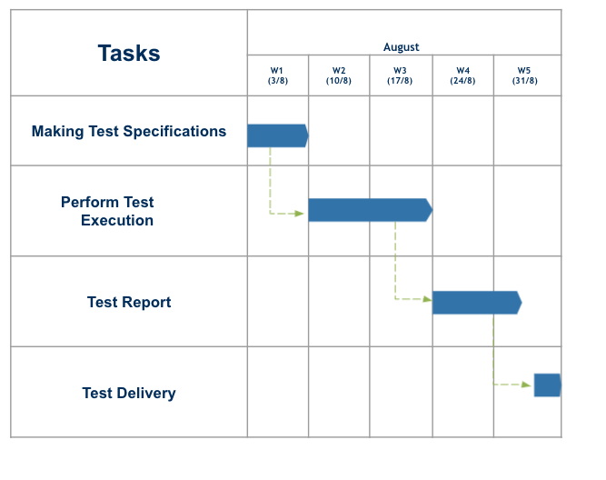

|  |  |  |
| --- | --- | --- |
| **Task** | **Members** | **Estimate effort (man-hour)** |
| Create the test specification | Tester | 120 |
| Perform Test Execution | Tester | 40 |
| Test Report | Tester | 15 |
| Test Delivery |  | 25 |
| Total |  | 200 |

1. Test Deliverables

7.1. Before testing

* Test plans documents
* Test cases documents
* Test design specifications

7.2. During the testing

* Test Tool
* Test Data
* Test Trace-ability Matrix
* Error logs and execution logs

7.3. After the testing

* Test Results
* Defect Report
* Test procedures guidelines for support team
* Release notes
* Sign off form